Course Methods Year 12 test four 2022

Student name: ________________ Teacher name: ________________

Task type: Response

Time allowed for this task: _____40______ mins

Number of questions: ____6_______

Materials required: Upto 3 calculators/classpads allowed

Standard items: Pens (blue/black preferred), pencils (including coloured), sharpener, correction fluid/tape, eraser, ruler, highlighters

Special items: Drawing instruments, templates, one page of A4 notes doublesided

Marks available: ___44___ marks

Task weighting: _10___%

Formula sheet provided: Yes

Note: All part questions worth more than 2 marks require working to obtain full marks.

Q1 (4 marks) 4.2.5
The exam results, out of a 100, for a Methods exam at a particular school was found to be Normally Distributed. It was found that 21% of the students scored a result greater than 85 and 17% scored a mark less than 55. Determine the mean and standard deviation.

Solution
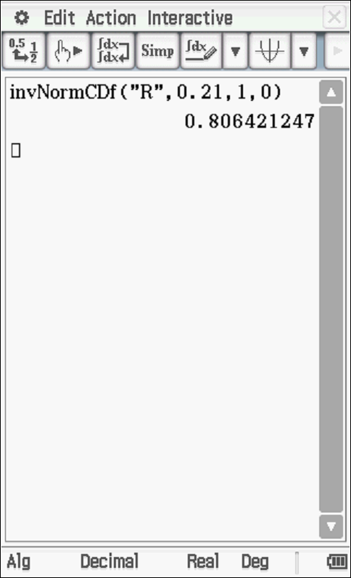
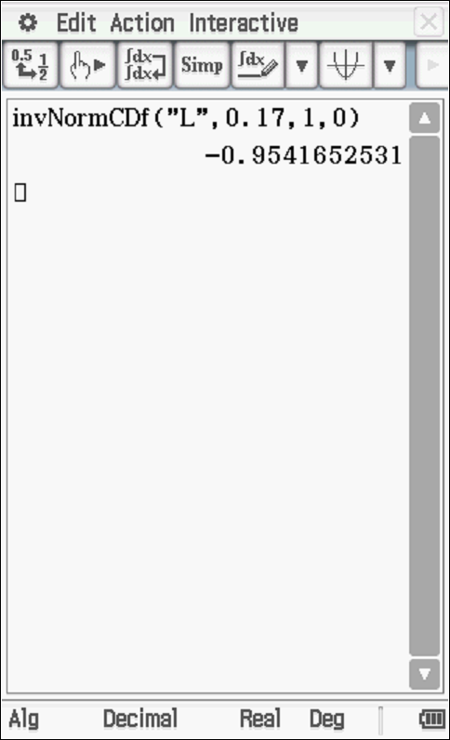

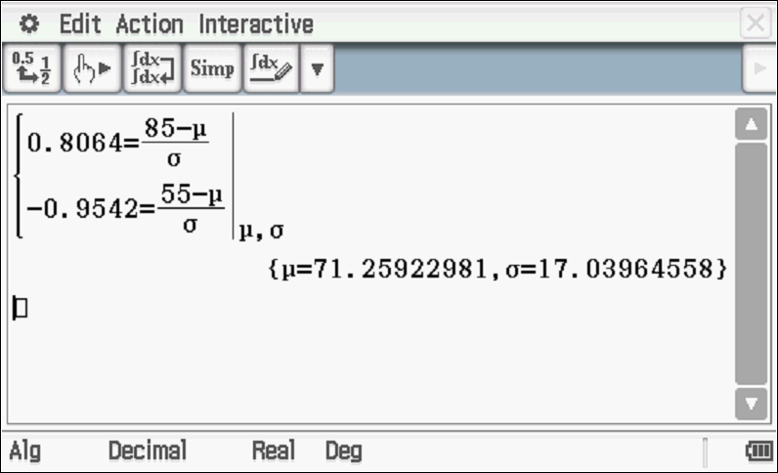

Specific behaviours
determines both z scores
sets up one equation for mean and stdev
sets up two equations for mean and stdev
solves for mean and stdev
Note- answer only max of 2 marks

Q2 (2, 2, 3 & 2 = 9 marks) 4.3.8
A 95% confidence interval was determined for the proportion of faulty factory parts made at a company. The interval length is 0.106 and the sample size of 200.
Determine the expected length of the interval for each change in isolation to 3 decimal places.

- A sample size of 300 was used.

Solution
Specific behaviours
uses correct ratio
states length rounded to 3 dp

- A 90% confidence was used.
Solution
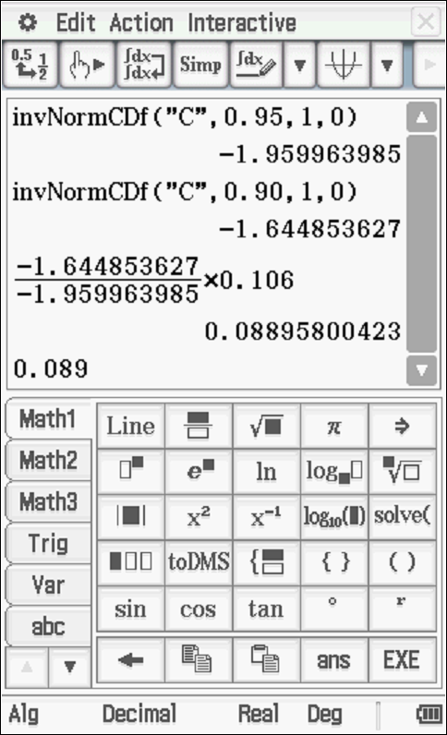

Specific behaviours
uses z quantiles
states length to 3dp (Do not double penalise if not 3dp)

- A 88% confidence AND a sample size of 150 was used.

Solution
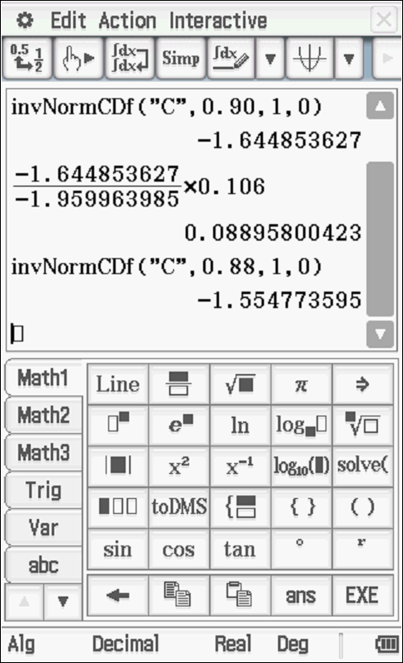

Specific behaviours
states quantile for 0.88
shows ratio involving sample sizes
states length

- The true proportion of faulty parts does not lie in the stated interval. Does this suggest a sampling error was made? Justify.

Solution
Cannot tell if there is a sampling error as not all confidence intervals contain the true value of population proportion p.

Specific behaviours
states no with any reason
states reason as above
(Note – zero marks if no without any reason)

Q3 (2, 2 ,2, 3 ,3, 3 & 3 = 18 marks) 4.2.5, 4.2.3, 3.3.1, 3.3.6, 3.3.7
A parcel making factory makes boxes of the same width and heights nut the lengths vary and are found to be Normally Distributed with a mean of 135 mm and a standard deviation of 27 mm.

- Determine the percentage of boxes that are longer than 166mm.

Solution
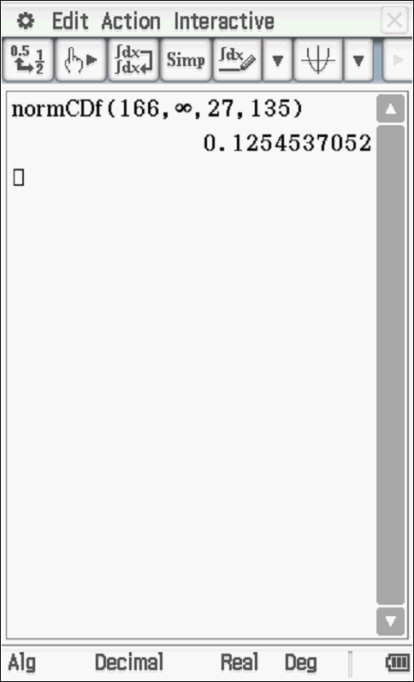

Specific behaviours
uses correct parameters
states prob

The boxes can be classified as the following.

- Complete the missing probabilities in the above table.
Solution
Box | Short | Long | Very Long | Gigantic
Length | 0 to 45 mm | 45 to 100 mm | 100 to 140 mm | Greater than 140mm
Probability | 0.00043 (0.000) | 0.097 | 0.476 | 0.427

Specific behaviours
Prob for short
Prob for Gigantic
(Must be at least 3 dp- otherwise -1 mark)
Note SCSA do penalise if not sufficient dp regardless of whether asked or not.

- Comment on the appropriateness of the Normal Model for the lengths of the boxes.

Solution
Normal model goes from – infinity to plus infinity, both of which are impossible/impractical.

Specific behaviours
discusses negative values
discusses unlimited positive values

- If 30 boxes were taken off the assembly line, determine the probability that exactly 13 were gigantic lengths.

Solution
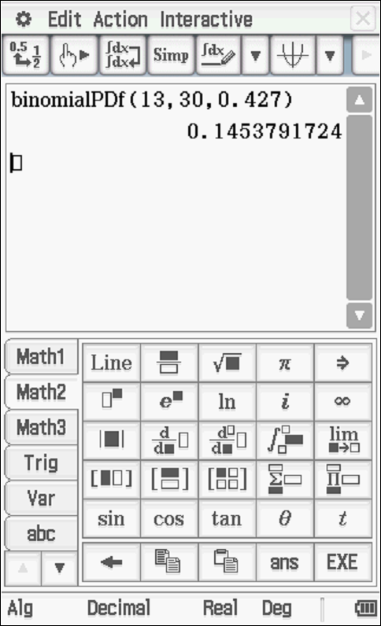

Specific behaviours
states Binomial with parameters
uses x=13
states prob (no need to round)

- Determine the probability that it would take 20 boxes in a row off the assembly line before 8 gigantic boxes were found.

Solution
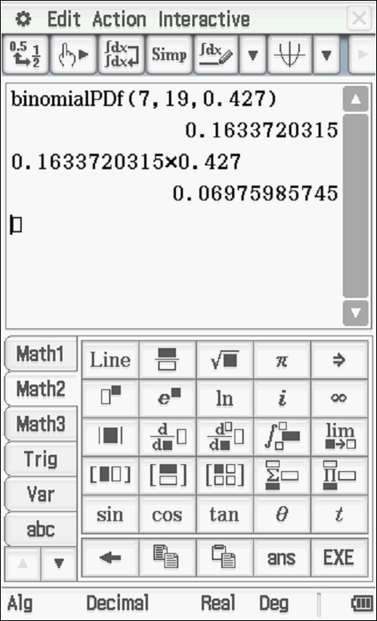

Specific behaviours
states Binomial with n=19
determines prob for x=7
states total prob (no need to round)

Continued on next page

Q3 cont
If the costs of each box were determined as follows.
Box | short | long | Very long | gigantic
Cost $ | $3.21 | $4.12 | $5.20 | $6.30

- Determine the mean cost to two decimal places. Show all working.

Solution
Specific behaviours
multiplies each x score by prob
shows total series
states mean to 2 dp

- Determine the standard deviation to two decimal places. Show all working.

Solution
Specific behaviours
subtracts mean from each x value and squares
shows total series
states stdev to 2dp
(Note max of -1 for total question for rounding errors)

Q4 (3, 2 ,3, 3 & 2 =13 marks) 4.3.4, 4.3.5, 4.3.6, 4.3.9, 4.3.10
In Australia it has been found that 16% of people are left-handed. Samples of people are surveyed to ascertain the proportion that are left-handed. Let denote the proportion of people in the sample who are left handed.

- State the approximate distribution of for sample sizes of 100.

Solution
Specific behaviours
states normal
states mean
states stdev

- Determine the approximate probability that in a sample of 300 people that the proportion of left handed people is greater than 0.21.

Solution
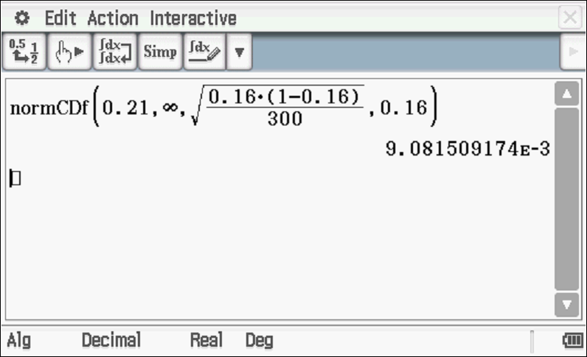

Specific behaviours
uses correct paremeters
states prob

Q4 cont-

In a recent survey it was found that 18 people out of a sample of 200 were left handed.
- For a 99% confidence interval, what is the margin of error based on this recent sample of 200?

Solution
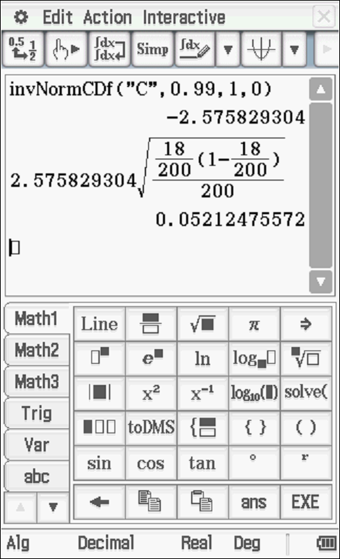

Specific behaviours
determines z quantile
shows working for margin of error
determines margin of error

- Determine a 95% confidence interval based on the recent sample of 200 people.

Solution
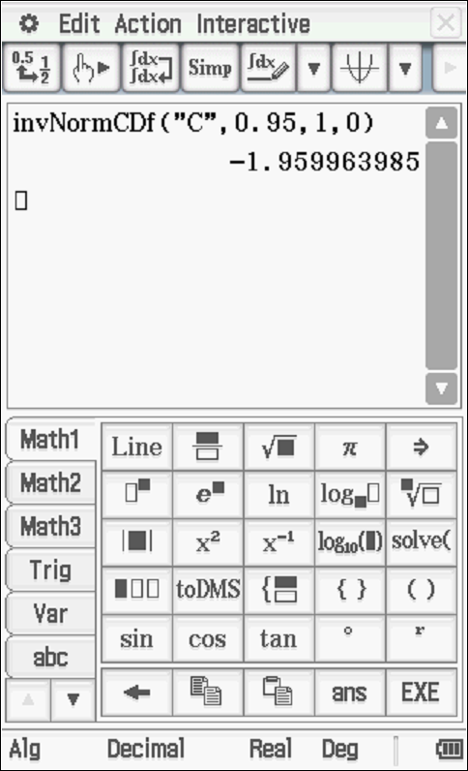

Specific behaviours
determines z quantile
shows working for confidence interval
states interval
Note: 2 marks for answer only

- Does the recent sample support the assumed proportion of 16% for left handed people? Explain.

Solution
The recent sample does not support the assumed model as 0.16 does not fit in the interval. (SCSA preferred answer)
OR
One sample cannot be used to make an inference as not all confidence intervals contain the true population p

Specific behaviours
states that support cannot be made with any reason
one of the reasons stated above

Working out space

